Assignment 10
Bharat Unnati AI Fellowship
CodeXpert

Assignment 10
Name: PRATHVIRAJ GOWDA
USN: 1CR22CD034
College: CMR INSTITUTE OF TECHNOLOGY

Topic:
Syntax for Class Declaration and Object Creation Across Languages

Syntax for Class Declaration
Below isacomparativetable showinghowtodeclare a class named Product across different programming languages.
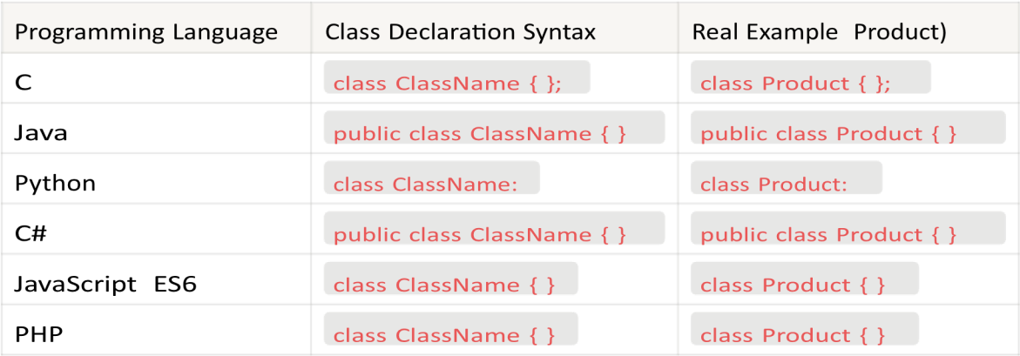
1
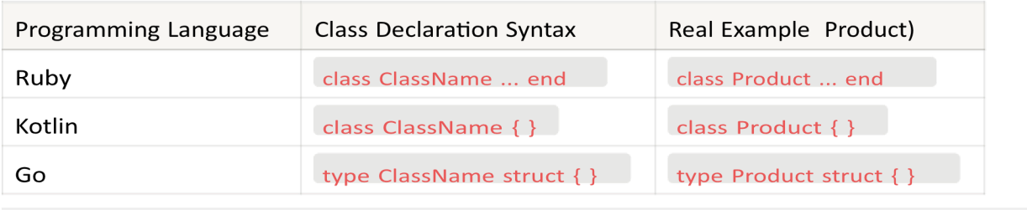

Syntax for Object Instantiation (Creation)
Onceaclassisdefined,creatinganobject(instance)differsslightly depending on the language.
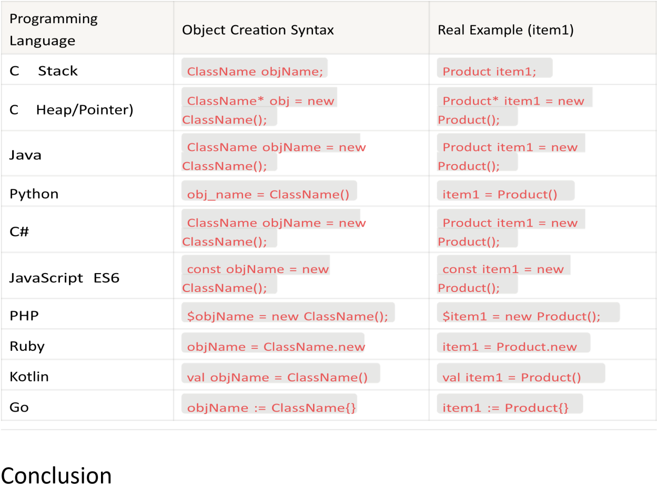
Thisassignmentprovides a comparative understanding of how different programming languages implement class declaration and object creation.
Despite syntactical differences, the core concept of object-oriented programming remains consistent across languages, helping developers adapt easily between different ecosystems.

